DLD Lab 08
(Software)

23K-2001
Muzammil Siddiqui
BCS 2-J
Exercise#1:
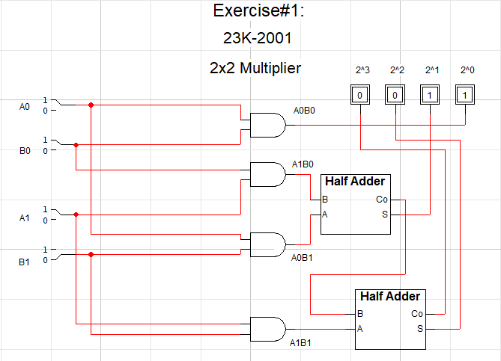

Truth Table for Exercise#1:

A0 | A1 | B0 | B1 | OUTPUT | IN DECIMAL
0 | 0 | 0 | 0 | 0000 | 0
0 | 0 | 0 | 1 | 0000 | 0
0 | 0 | 1 | 0 | 0000 | 0
0 | 0 | 1 | 1 | 0000 | 0
0 | 1 | 0 | 0 | 0000 | 0
0 | 1 | 0 | 1 | 0100 | 4
0 | 1 | 1 | 0 | 0010 | 2
0 | 1 | 1 | 1 | 0110 | 6
1 | 0 | 0 | 0 | 0000 | 0
1 | 0 | 0 | 1 | 0010 | 2
1 | 0 | 1 | 0 | 0001 | 1
1 | 0 | 1 | 1 | 0011 | 3
1 | 1 | 0 | 0 | 0000 | 0
1 | 1 | 0 | 1 | 0110 | 6
1 | 1 | 1 | 0 | 0011 | 3
1 | 1 | 1 | 1 | 1001 | 9

Exercise#2:
